--[Type a quote from the document or the summary of an interesting point. You can position the text box anywhere in the document. Use the Drawing Tools tab to change the formatting of the pull quote text box.]

Dear Friends,

While 2020 has been an unpredictable and a difficult year in many ways, there is still so much to be thankful for which includes all of the St. Joseph’s Nursing Home family. In fact, over the past months, at times, the pandemic itself afforded all of us the opportunity to take a deeper, reflective glance at the really important things in our life and society. We saw on the local news many uplifting stories of creativity used to reach out to neighbors, even strangers, in need as we all struggled with stay-at-home orders and endless changing restrictions.

St. Joseph’s Nursing Home was no stranger to this goodness, as we were graced by your continual loving friendship in so many supportive ways. Your friendship and prayers are truly heavenly gifts to all of us here at St. Joseph’s. These are wonderful reflections of the spirit of Christmas. The goodness of God has showed itself brightly in your loving concern and we delight in each of you being a priceless gift to the St. Joseph’s family.

We are pleased to announce that plans for finishing the renovation project are in order. We continue to make the appropriate plans for upgrading the facility to make St. Joseph’s more like a home. As we plan ahead, should you need another tax write-off for this fiscal year, we kindly ask that you consider our project. Any gift will be of great assistance to us. Above all, your prayers for a safe and successful completion of this final phase of the renovation would be greatly appreciated.

Christmas is a season of joy, hope and God’s love for each of us. As we await with great anticipation again the birth of the Christ child, we wish you continued blessings, comfort and peace at Christmas and the New Year.

In humble gratitude,

Sister Krystyna and Sisters

**Our Renovation Progress**

We had to slow the process on some of our renovations

in 2020. One project that was long overdue was the

renovation of our laundry room. New equipment, plus Air

Conditioning added a much needed update. The Laundry

Team works hard every day to make sure our residents

Have everything they need every day.

**Volunteers**

Our volunteers have found special ways to help during the Pandemic. We appreciate all of their creative efforts on helping to make our jobs easier and more enjoyable. Whether it was making masks, bringing much needed supplies, being nominated to receive a free lunch or to find ways to entertain us, we have experienced wonderful gestures from our community.



!

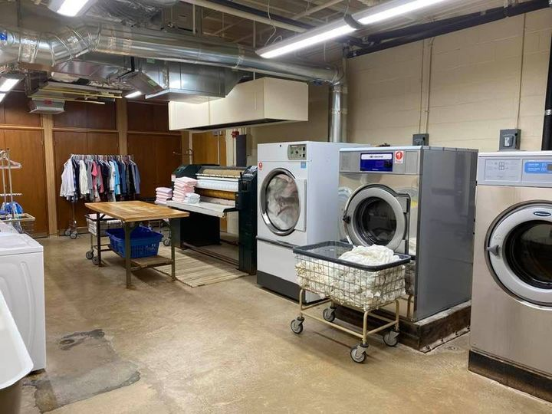

410-747-0026

<http://www.stjosephs.net/>

1222 Tugwell Drive ~ Catonsville, Maryland 21228

ST. JOSEPH’S NURSING HOME

A Ministry of Sisters Servants of Mary Immaculate

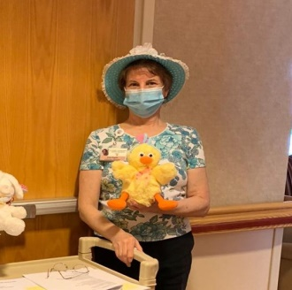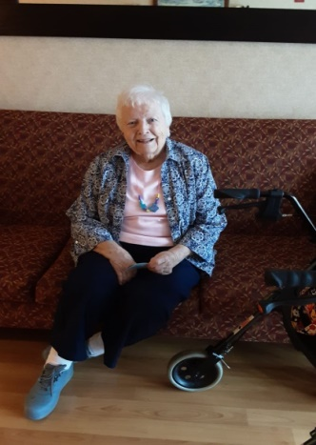

Mrs. Mary Watkins was no stranger to St. Joseph’s when she joined us before Christmas last year. Her mother was also a resident with us in the 1990’s. It is a blessing that generations of families have continued to join us throughout our years of service.

With the pandemic, special ways were created to help communicate with our residents’ loved ones. Ms. Mary got to experience all of the technology changes the Activities Department provided. Ms. Mary had just finished a video chat with her daughter right before this picture was taken. She would always get herself dressed up before each video call with her family.

**Employee Spotlight**

**Our Residents**

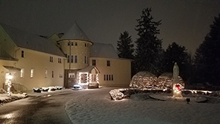

Figure 1: Mary is wearing a homemade necklace created by her Great Granddaughter.

**Figure 2: Irene is seen here going room to room to brighten our residents’ day!**

The Convent at Christmas time! The Sisters love to make everything Festive.

**Our Annual Golf Tournament**

Our Activities Department has been led by Irene for over 6 years and many changes have occurred during this time of uncertainty. She has made sure that all residents are receiving attention as much as possible. Schedules of activities still include time for the Rosary; Sing a Longs, and personal and small group talks. She even has conducted sing a longs to individual rooms when our Residents were under quarantine. Thank you, Irene, for all you do!

Christmas will arrive on December 25, 2020, but we do not know how that will look just yet. I assure you that St. Joseph’s Nursing Home will be decorated for the occasion and filled with the Spirit to welcome our New Born King. We continue to hold each and every one of you in our prayers.

**Christmas 2020**

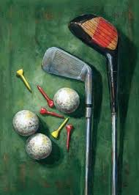

With great disappointment we had to cancel our annual golf tournament due to the pandemic. Thank you for all of the support we received from our friends and family. We will see you next year in 2021.

Christmas at St. Joseph’s Nursing Home is truly special with our Polish Sisters. The decorations are spectacular and they make St. Joseph’s a Home away from Home. We are so grateful for all of their hard work.

The Congregation of the Sisters Servants of Mary Immaculate was called to life in the Church on October 7, 1878, (Feast of Our Lady of the Rosary), by Blessed Father Honorat Kozminski, a Polish Franciscan Capuchin.

The Main goal of the Congregation can be stated:

"Guided by the Immaculate Virgin Mary, the Sisters are to spread the word of God, to help individuals strengthen their lives of faith and Christian morals, to increase devotion to the Blessed Virgin Mary by imitating Mary's hidden life, to encourage others by their good example and deeds, and also by praying for the world and its particular needs through the recitation of the Rosary."

(Constitution 1881)

**Sisters Servants of Mary Immaculate**