Advent 2022
ST. JOSEPH’S NURSING HOME
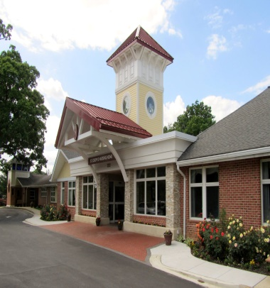
The 2022 2nd Annual Carry-Out Crab Feast!
We would like to thank everyone for your support, thoughts, and prayers for our 2nd Annual Carry-Out Crab Feast. It was a beautiful day filled with many smiles from old and new friends!
Mark your calendars for September 16, 2023 for our 3rd Annual Fundraiser!
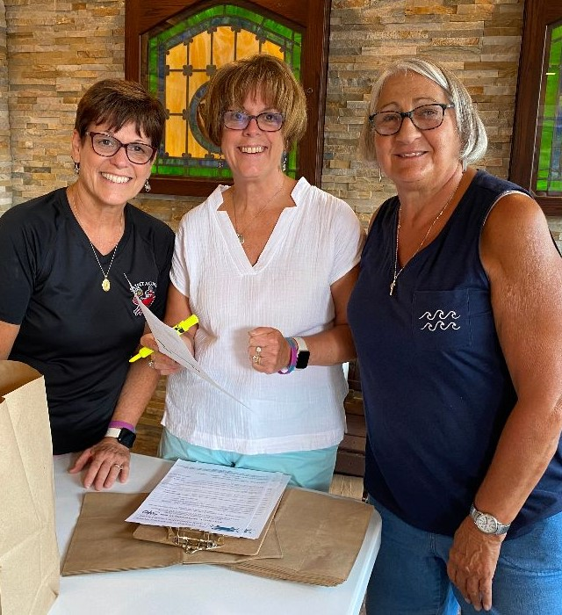
Sue Bianco, Linda Caton, and Sue Thompson filling out orders!
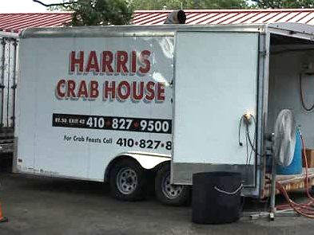
Crabs steamed from Harris Crab House and Catering from Monaghan’s Pub!
1222 TUGWELL DRIVE, CATONSVILLE, MD 21228
www.stjosephs.net 410-747-0026
Dear Friends,
As the temperature turns cooler, we are reminded that soon the beautiful events of Christmas will be celebrated. We all have so much to be thankful for to our Almighty God; the gift of His Son and our Lord Jesus at Christmas, the gifts of family, faith and friends, the gifts of our various freedoms and democracy. The entire St. Joseph’s Nursing Home family counts your loving friendship and constant support as a gift at the top of any list. Without your thoughtfulness and generosity, St. Joseph’s would not enjoy its reputation for quality care and services. We are all so very appreciative of your being part of the St. Joseph’s family.
One of the many expressions of your terrific support has just recently been seen. I hope you have heard that the crab feast with all its extended activities; the cash raffle, virtual golf, the gift baskets, etc. was a great success. Thank you each and everyone for helping our fundraiser to be successful along with being so much fun! We have already established a date for next year, September 16, 2023!!
Should anyone need another tax exemption for this year, we would like to remind you that our renovation fund is still active. Meetings are being held and plans are being revised as we await approval from Baltimore County for the final phase of the resident rooms’ renovation project. As a reminder, we do have access to a stockbroker should you have any stock to share.
With appreciative and thankful hearts, all of us here wish you and your loved ones a truly blessed and peaceful Christmas. Please keep all of us at St. Joseph’s in your prayers as you are remembered in our daily thoughts and prayers. May the soon-to-be born Infant King and His Immaculate Mother always be close to you with their protection and guidance.
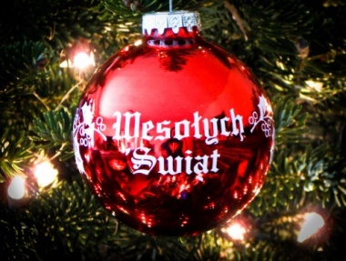
Thank you again for all your love and generous hearts. We are truly blessed!!!
This Photo by Unknown Author is licensed under CC BY-SA
Stay well and safe!!!!
With gratitude and prayers,
Sister Krystyna and Sisters
4-H Helps St. Joseph’s

Two Special Birthdays!

We celebrated two special ladies this Fall! Ms. Jane turned 100 years young in September and Ms. Irma reached 103 in October! We are so lucky to have them at St. Joseph’s!
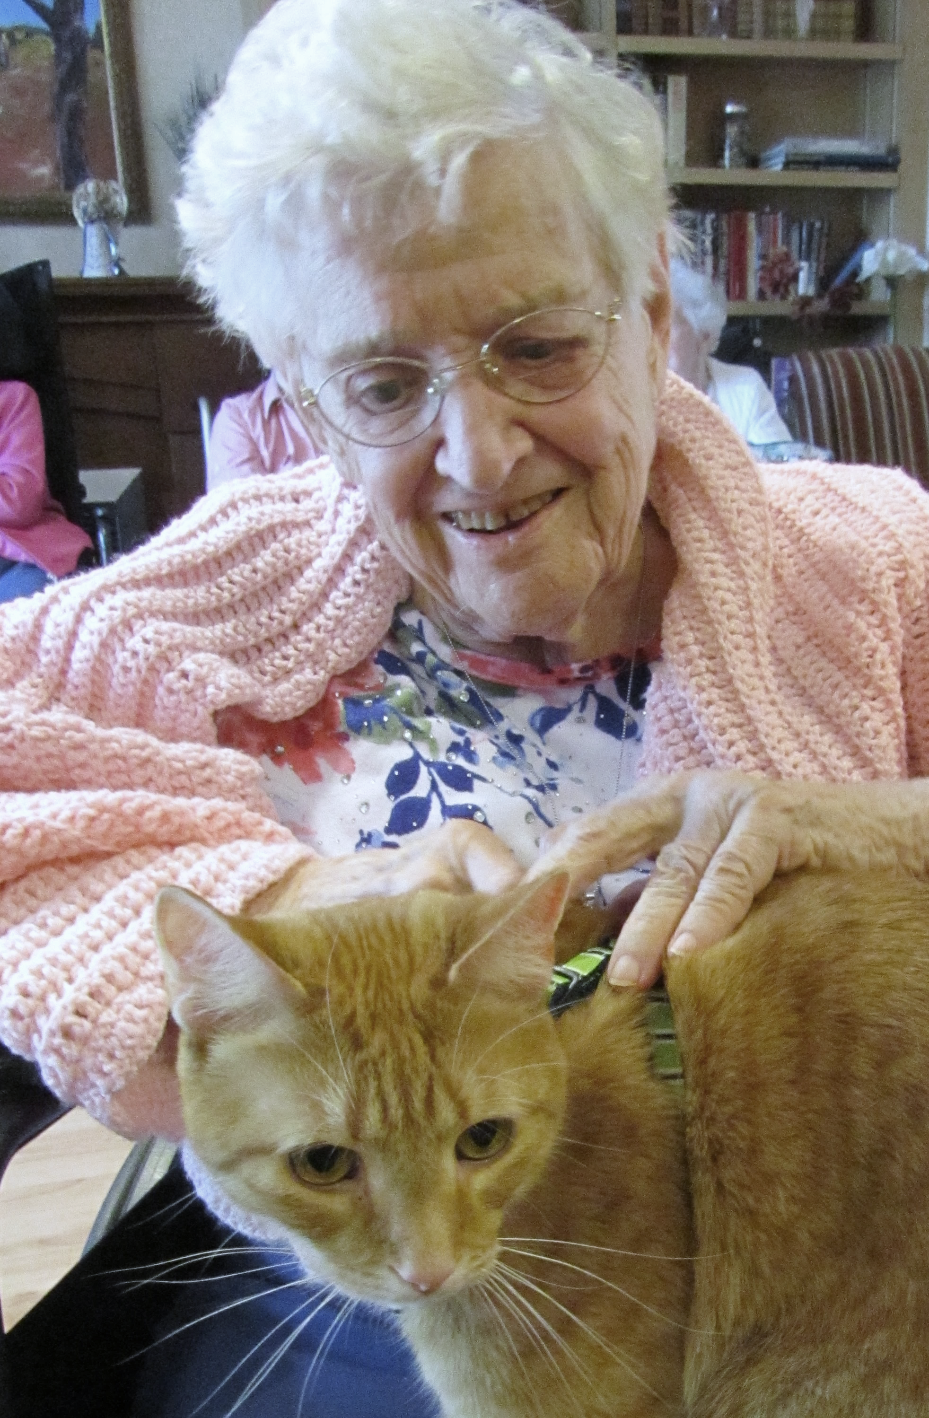
100 years looks good on you, Jane!
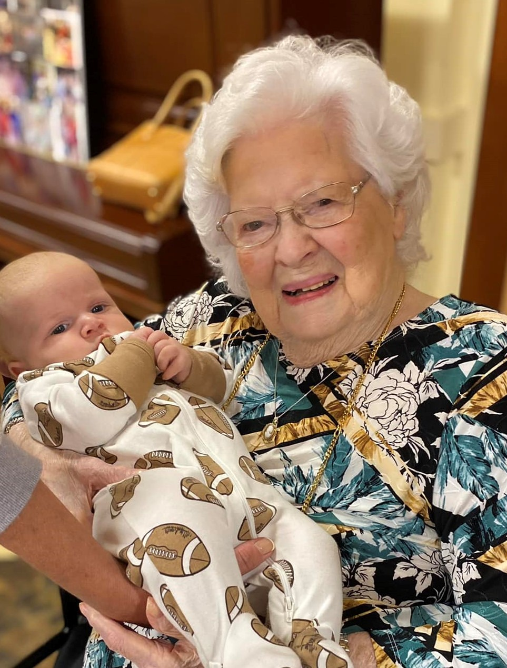
Irma is pictured here with her 8th Great, Great Grandchild!
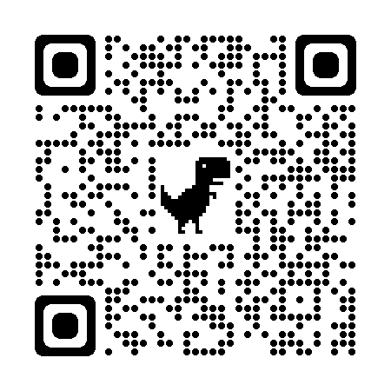

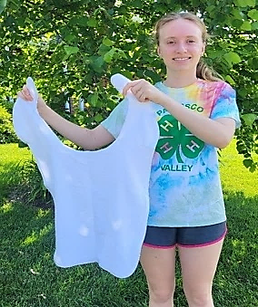
Recently, Howard County 4-H member Hazel Helm completed her 4-H Diamond Clover 6 project. First, she held a fundraiser to purchase materials to make 80 adult bibs for St. Joseph’s Nursing Home. The Patapsco Valley 4-H Club, of which Hazel is a member, helped her cut out all the bibs, which she then sewed over a period of two and a half months. Hazel also created the Senior Citizen Service Guidebook. This guide is for 4-H Members and Leaders to assist in planning of service projects at Senior Homes. It was created in hopes of increasing intergenerational activities among 4-H Clubs and the community. For additional questions, or for a copy of the guidebook, please contact the Patapsco Valley 4-H club at: patapscovalley@howaed4-h.org.

A Special Celebration

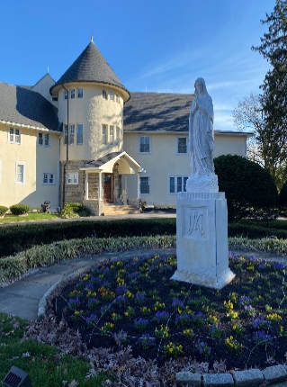
On Sunday, October 30, 2022, the Sisters Servants of Mary Immaculate celebrated 70 years as being a Province (a legal liturgical entity) in the United States of America. However, the Sisters have been here in America since 1934. The American Province is one of five such provinces in the Sisters Servants of Mary Immaculate Congregation worldwide. A Mass of Thanksgiving will be held for the countless blessings received over the year. With prayerful gratitude, past and present Sisters, friends, residents and benefactors will be remembered and celebrated. Congratulations, Sisters! May you all be blessed with many more years of such faithful service to the Church!!

A New Arrival
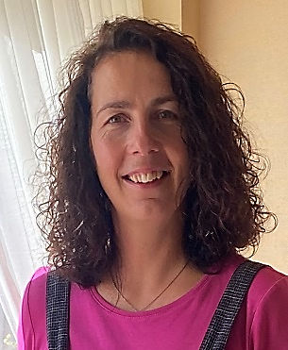
There is a saying “good things come to those who wait”. Well, the Sisters Servants of Mary Immaculate’s patience has recently received a dividend. Many years of patiently waiting, and even more countless prayers have now been answered, A new Sister Servant, Sister Maija, arrived from Latvia on September 11th to join the other sisters here in the America Province. Right now, she is getting adjusted to all things American and the various ministries of the other sisters. Welcome, Sr. Maija, happy to have you here with us!
IMPORTANT DATES
December 8^{th ~} Mass at 9am
Feast of the Immaculate Conception

Christmas Mass Times: Daily Mass Schedule:

December 24th at 7pm Monday ~ Saturday (Vigil) 9am

December 25th at 10am Sundays at 10am

